Broken Access Control & JWT Manipulation Testing Report
This document demonstrates the professional testing workflow for identifying Broken Access Control vulnerabilities
including Horizontal Privilege Escalation, Vertical Privilege Escalation, and JWT Token Manipulation in a vulnerable Flask application.
Tools Used:
- Burp Suite
- Kali Linux Terminal (curl)
- Firefox Browser
- JWT.io for token analysis

1. Application Running
Start the vulnerable Flask application. The server runs on http://127.0.0.1:5000 and initializes the database with test users.
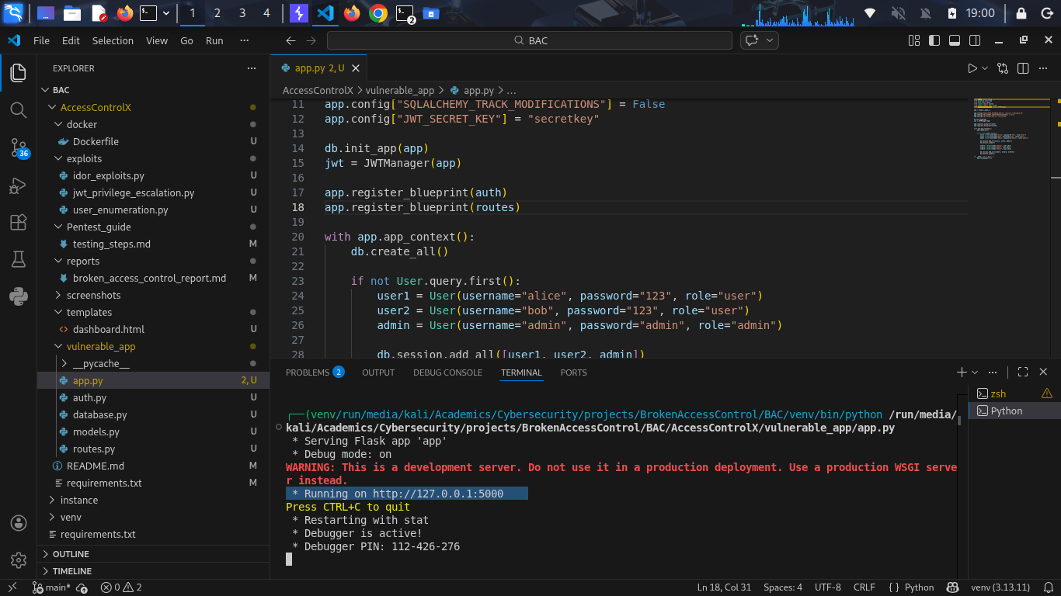

2. Configure Browser Proxy
Enable the FoxyProxy extension in the browser to route traffic through Burp Suite for interception and analysis.
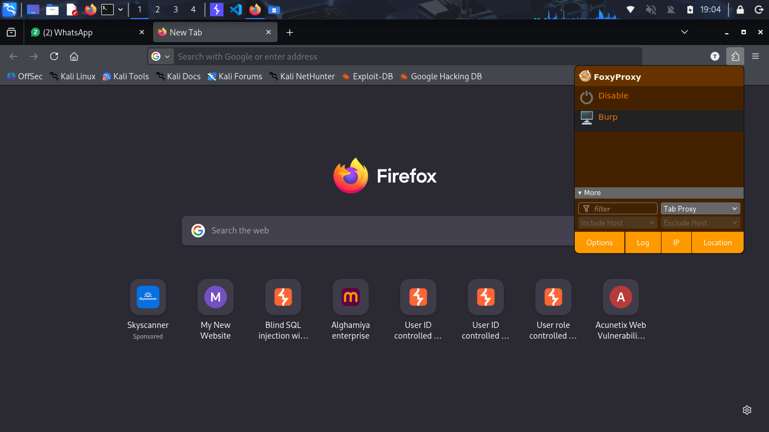

3. Burp Suite Interception Working
Verify that Burp Suite is capturing traffic successfully. HTTP requests from the browser should appear in the Proxy HTTP history.
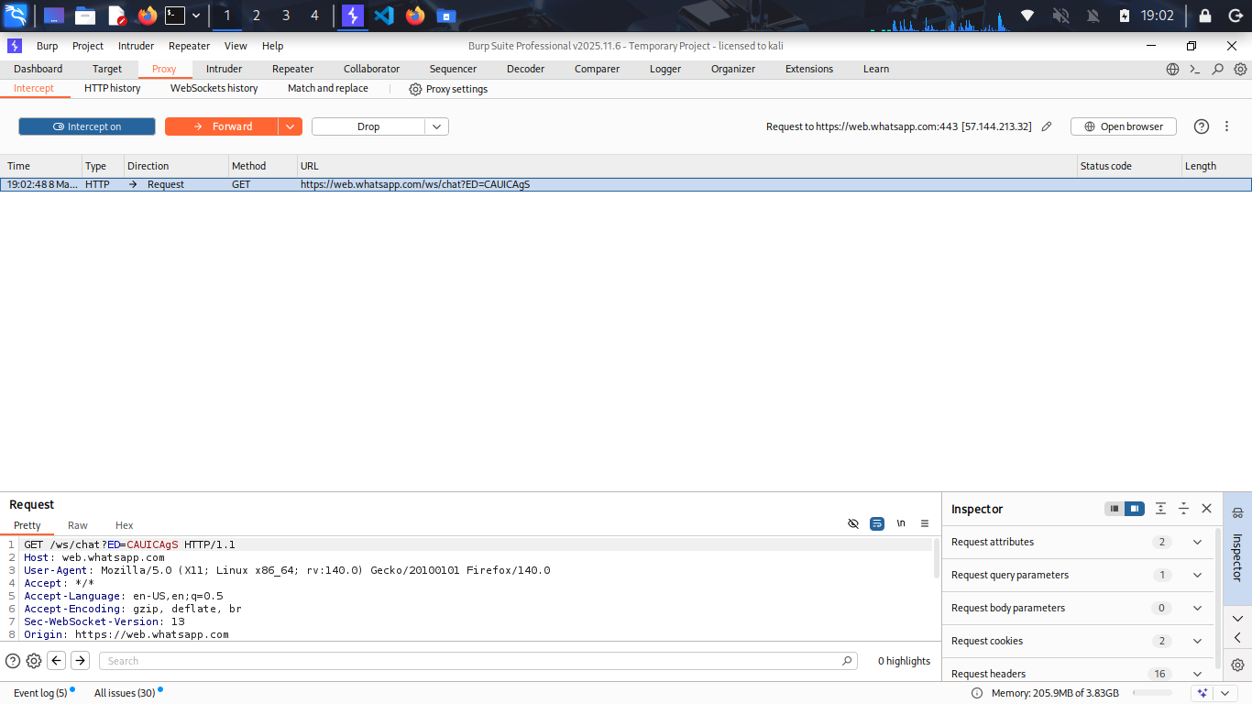

4. Login Endpoint Behavior
Accessing /login directly in the browser produces 'Method Not Allowed' because the endpoint only accepts POST requests.
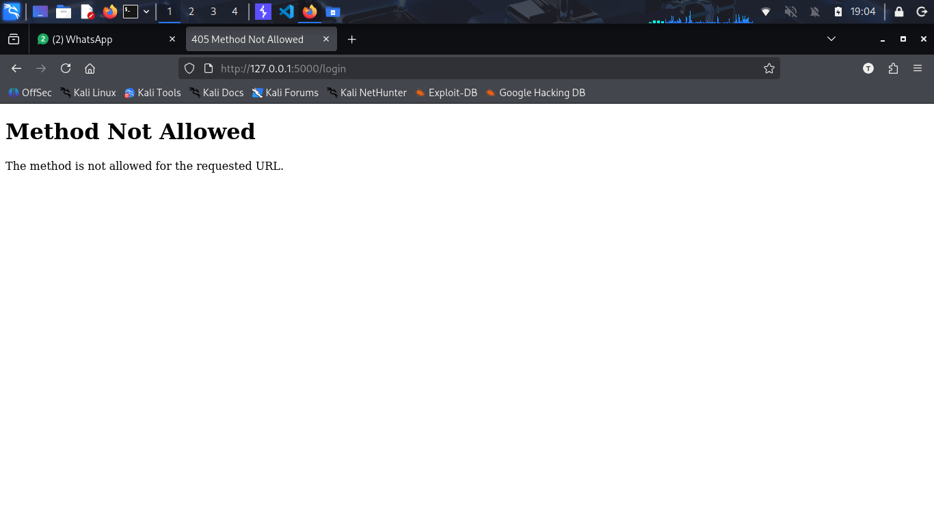

5. Send Login Request Through Burp
Use curl to send a POST request through the Burp proxy to capture the login request.
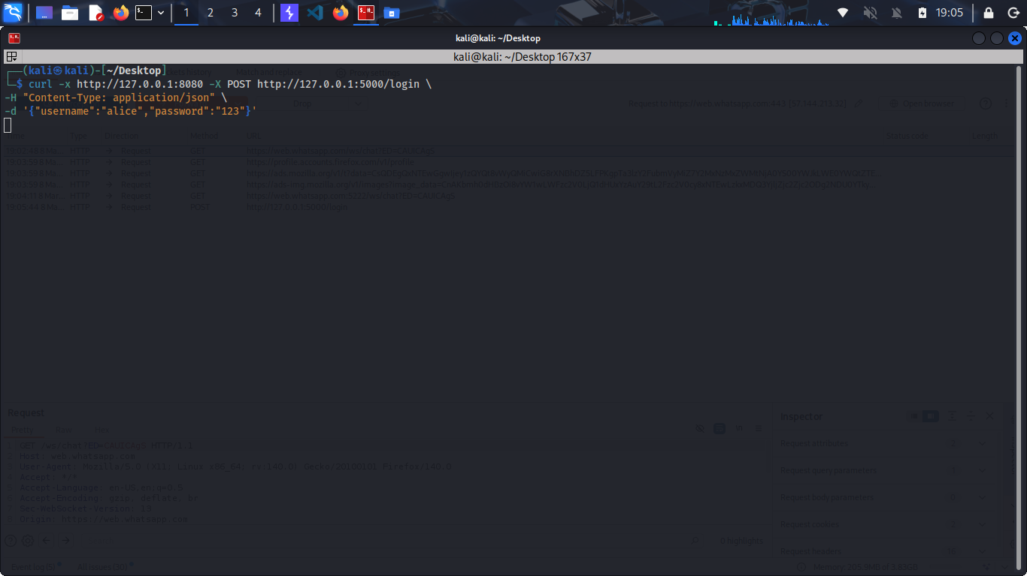

6. Captured Login Request
Burp Suite captures the login request containing JSON credentials for authentication.
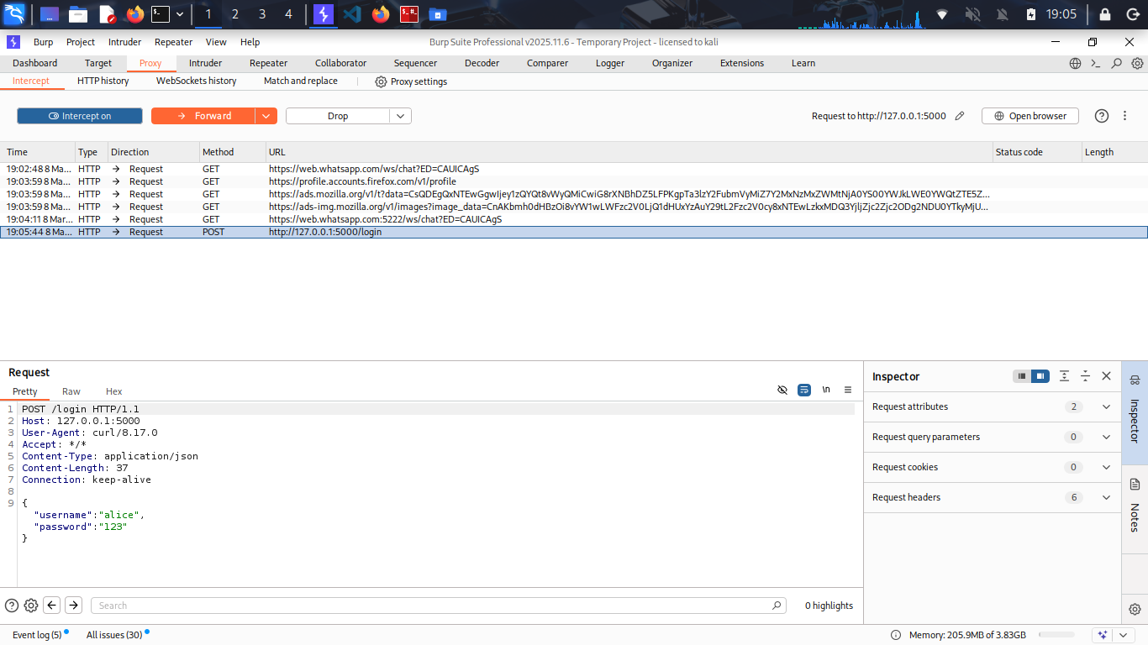

Send the /login request to repeater and send for response to get access token

7. Receive JWT Access Token
After successful authentication, the server returns a JWT access token in the response.
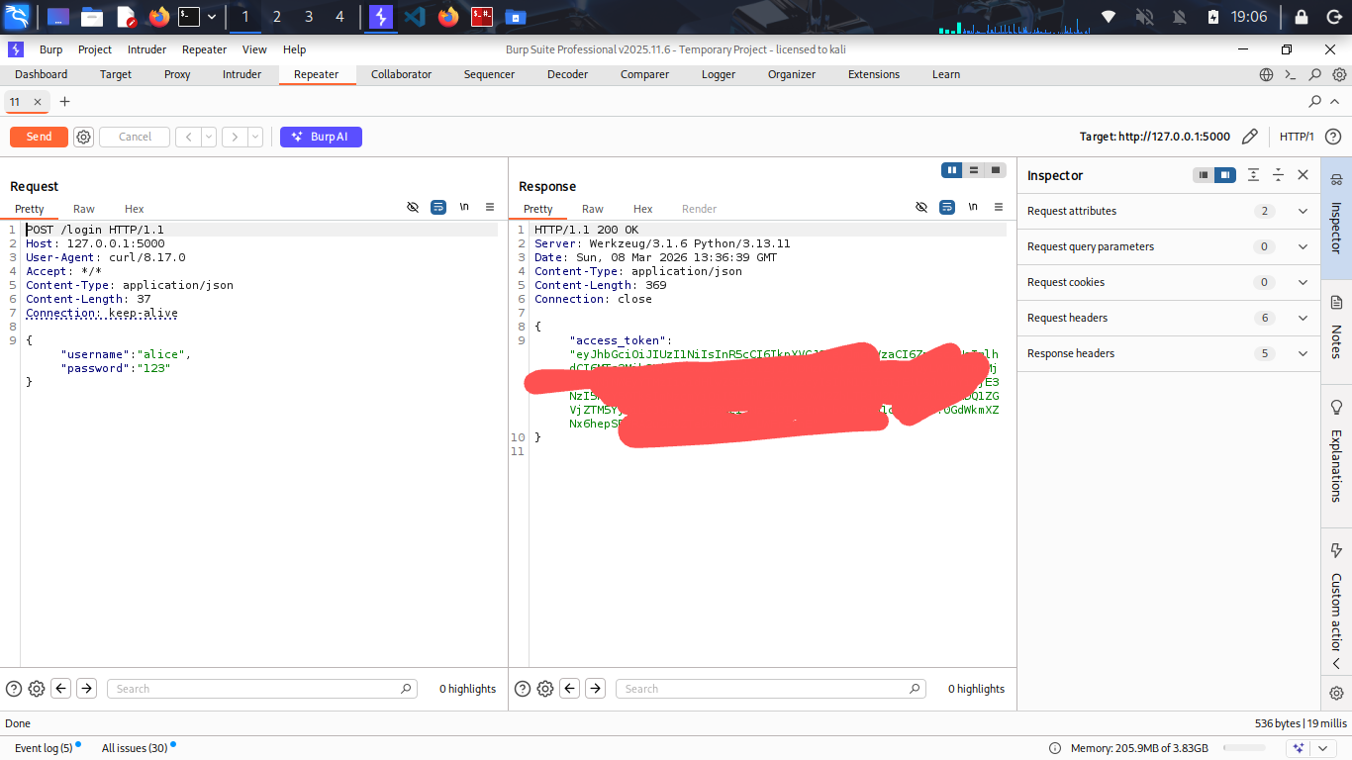

8. Access current User Orders
Using the JWT token, the user accesses their own order using the /api/orders/1 endpoint.
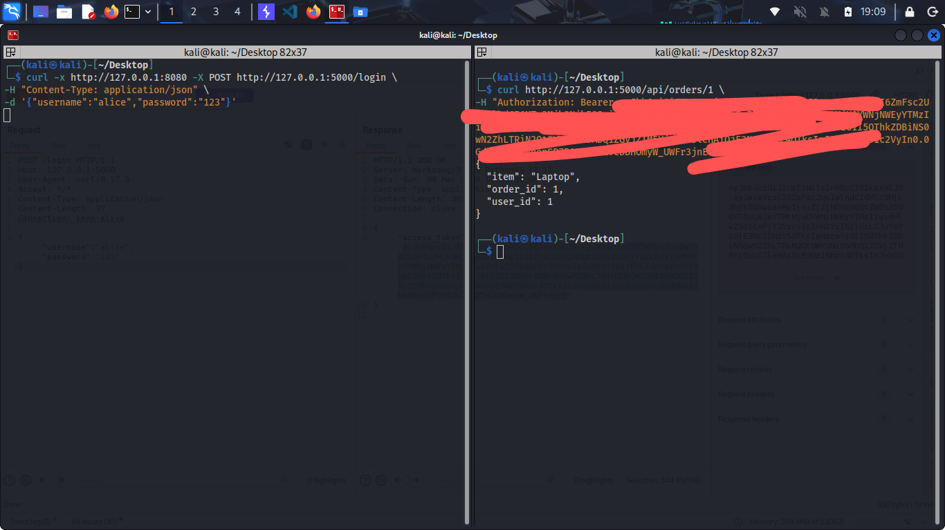

9. Horizontal Privilege Escalation (Access other user’s orders)
The user modifies the order ID to access another user's order, demonstrating an IDOR vulnerability.
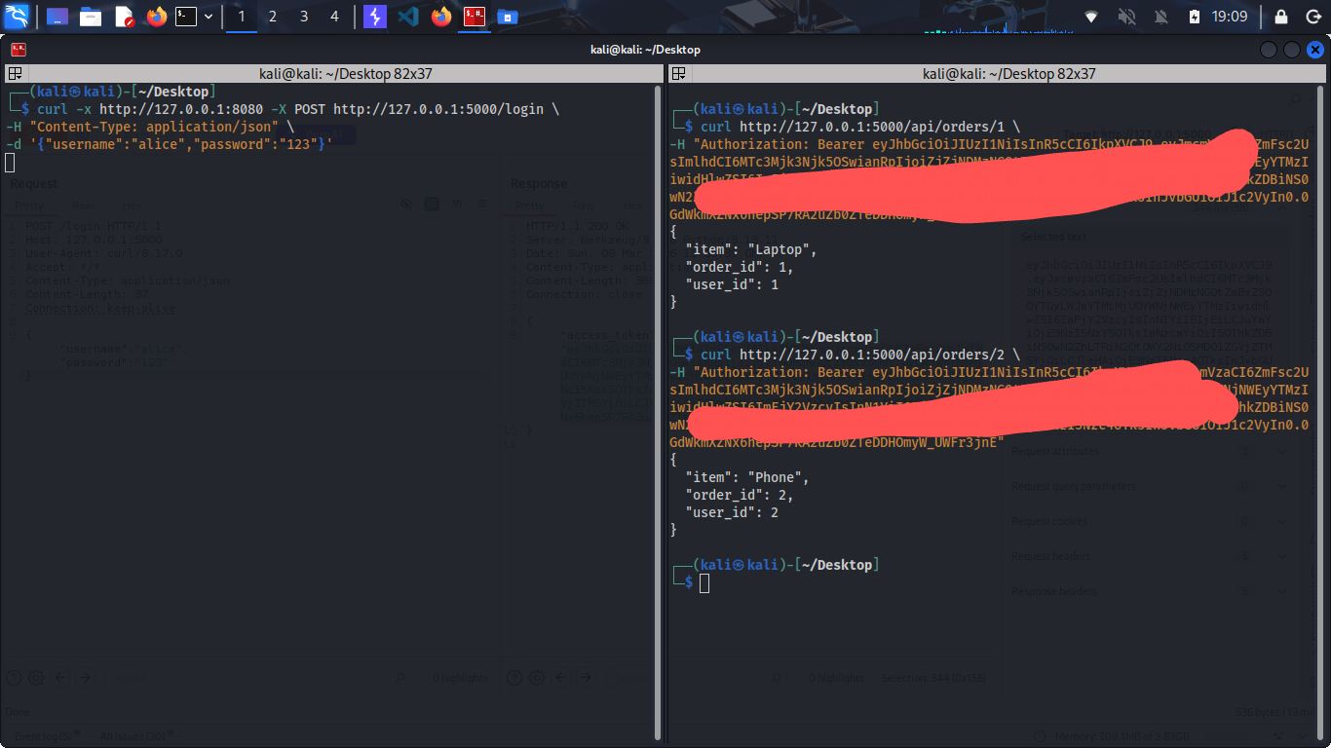

10. Vertical Privilege Escalation (access admin interface)
The attacker attempts to access an admin-only endpoint (/admin/all_orders).
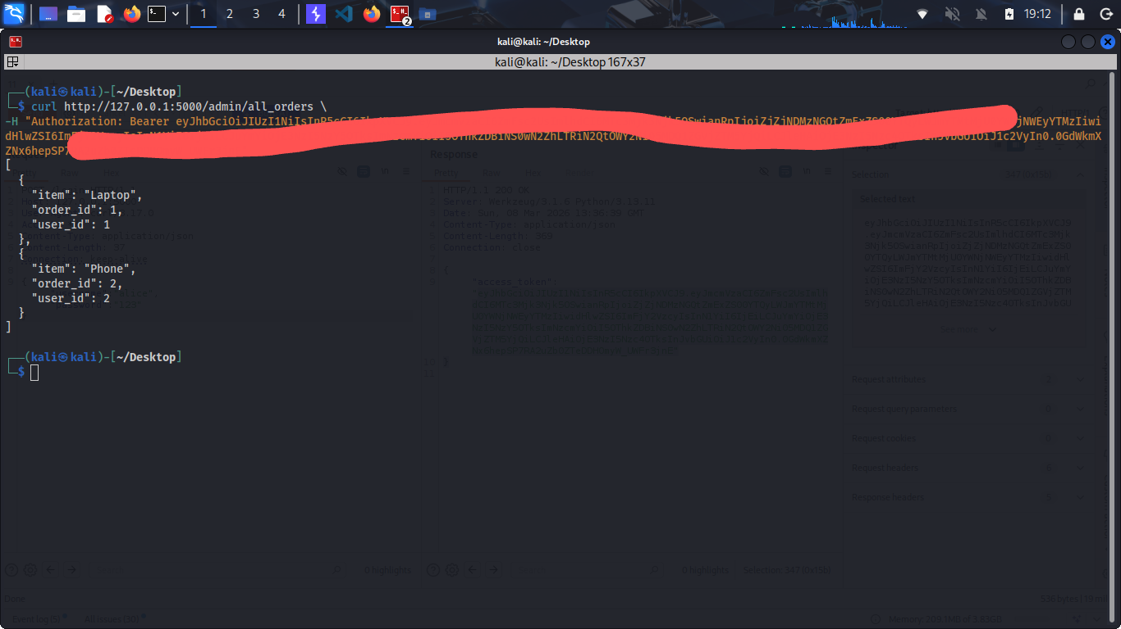

11. JWT Token Analysis
The JWT token is decoded using “JWT.io” to analyze its header and payload fields.
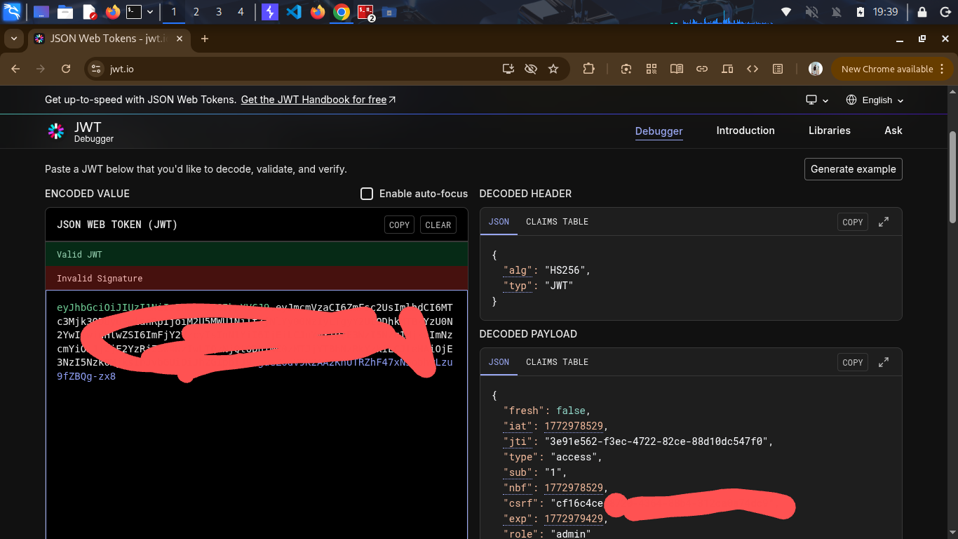

12. JWT Role Manipulation
The role value inside the JWT payload is modified to 'admin' and re-signed with the known secret key to escalate privileges.
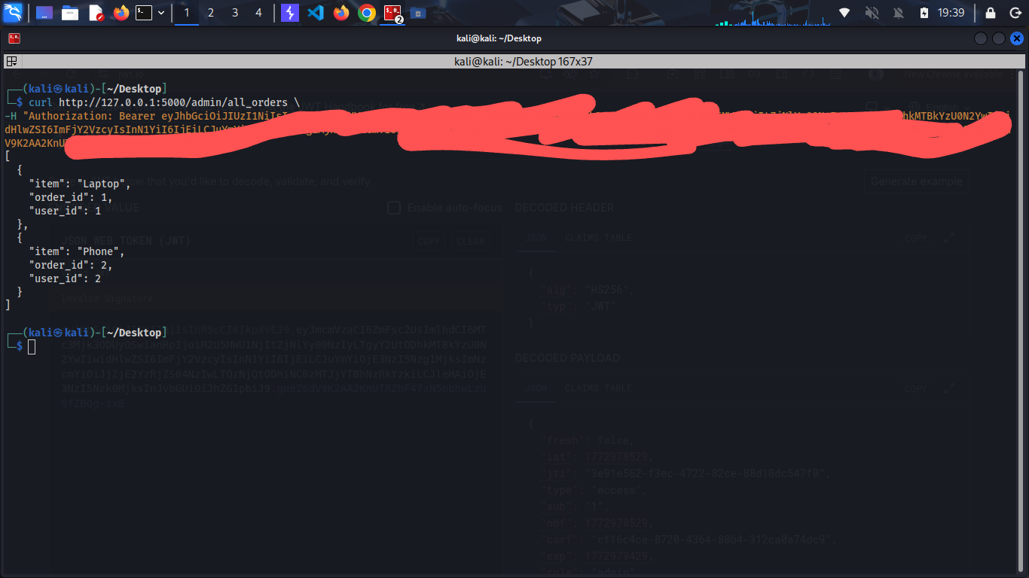

Conclusion
The testing process demonstrates how improper access control validation can lead to serious vulnerabilities.
The application allowed horizontal access to other users' data and vertical privilege escalation by manipulating
JWT token claims. Proper validation, role verification on the server side, and secure JWT handling are required
to prevent these attacks.

